**Basic Page Rank:**

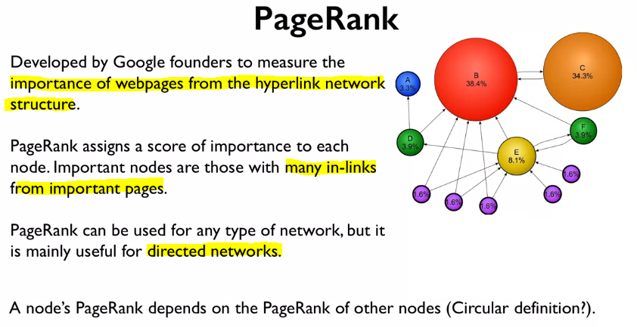

Imagine looking at one-page node, we want to assign an importance to that node, but we need the importance of all the other nodes pointing to it, so this method becomes circular. The method used to find this importance is a recursive method.

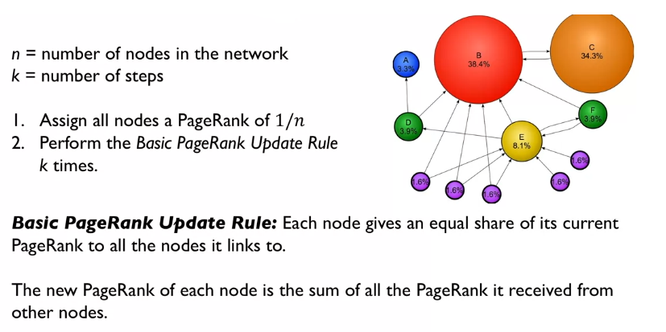

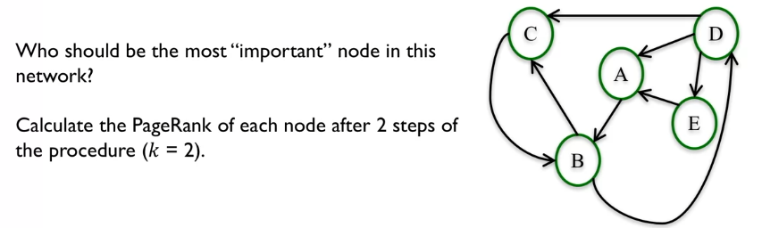

When we compute the page rank for a step we always use the initial node values not the new updated values until we reach the next step.

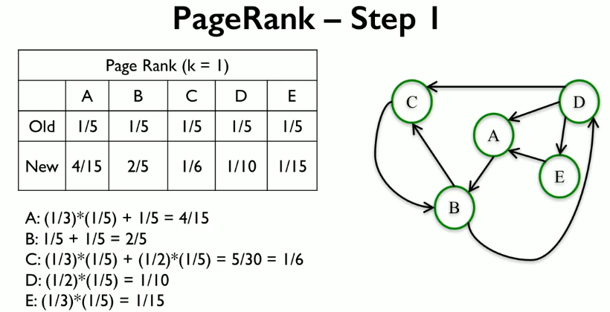

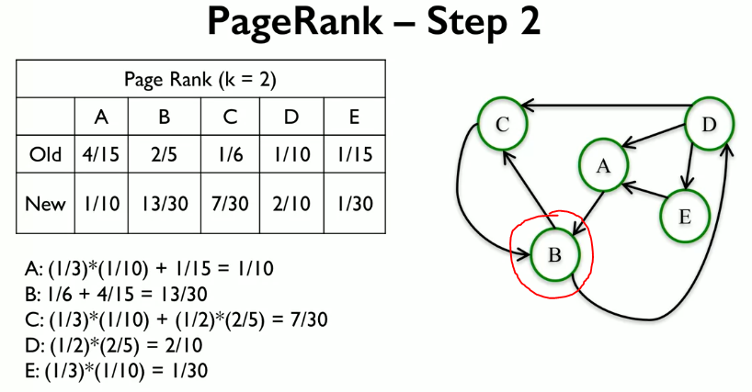

After just 2 steps we can see that node B is the most important.

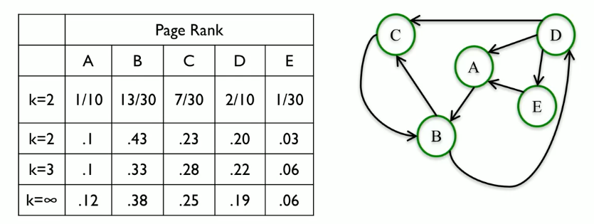

Its important to note that for most networks of web pages the values will converge. The converged page rank is the converged page rank.

